Step 1:- Login to ITSD portal
Step 2:- navigate to service catalog application service request apollo user creation
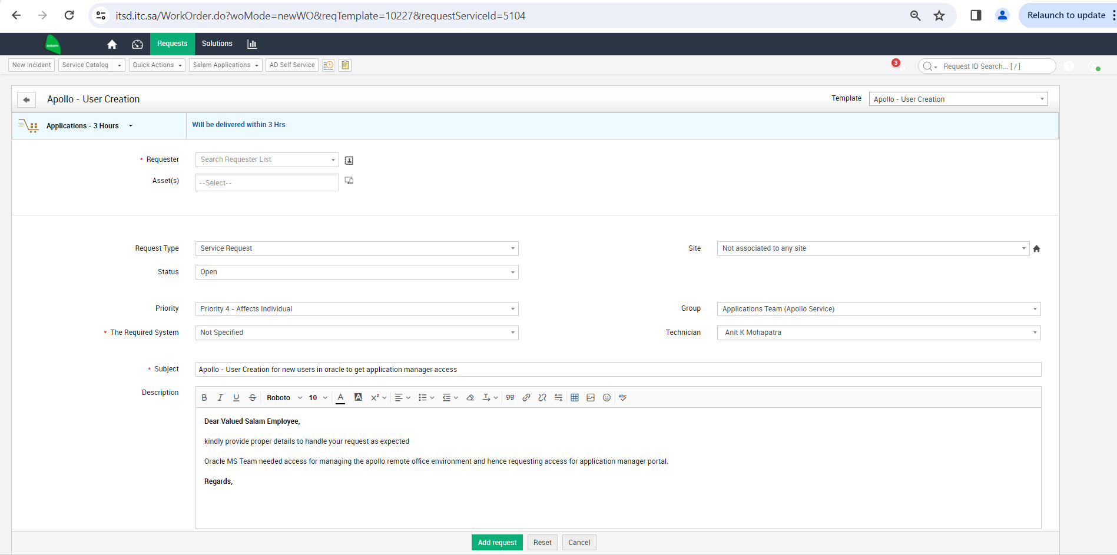
an page like above will be opened please provide justification as mentioned above for respective access request in this case I have referred app manager access request
the same form applies for
- Server access
- Access deletion
- App manager
- Infra ops manager
Update the below given sheet with user name and access stype required and attach to the ticket and click add request it will go through the work flow
(Note:- please keep this document updated as and when changes made in portal)

